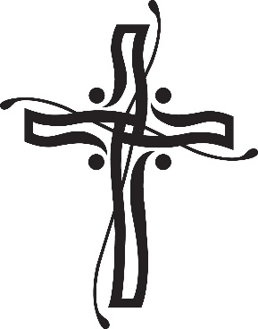
Castletown Girls’ School, Castletown Road, Dundalk, Co. Louth A91 P957
Tel: (042) 9334574. Roll No: 14651U
Email: castletowngs@gmail.com

Board of Management 2023 – 2027

Chairperson | Martina Rafferty
Patron Nominee | Brendan McKernan
Secretary/ Principal | Lisa Murphy
Teacher Nominee | Mairead Fearon
Parent Nominee | Wayne Dunne
Parent Nominee | Natalie Mc Kevitt
Community Nominee/ Treasurer | Aine O’ Brien
Community Nominee | Cormac Woods

