Contents
Introductory Statement | Page 1
School Information | Page 1
Rationale | Page 1
Belief Statement | Page 1
Aims of the Policy | Page 2
Roles and Responsibilities | Page 2
Identifying Pupils with Additional Needs | Page 6
Information Gathering and Assessment | Page 8
Inventory of Test Materials | Page 9
Prevention and Early Intervention Strategies | Page 9
Meeting the Needs and Allocating Resources | Page 10
Timetabling | Page 12
Tracking, recording and reviewing progress | Page 12
Health and Safety Issues | Page 15
Supervision/Child Protection | Page 15
Ratification and Communication | Page 15
Implementation and Review | Page 15
Castletown Girls’ School
Additional Support Policy
Support for All
September 2023

Introductory Statement
Our SEN policy was coordinated by the learning support team. The purpose of this policy is to review and amend the 2015 Special Education Needs policy in accordance with Circular No 0013/2017.

School Information
Castletown Girls’ School is an urban DEIS band 1 with a high population of EAL families and families from other ethnic backgrounds enrolled in our school.

The school currently has the following provisions to cater for children with Special Education Needs:
- 4 Special Education Teachers
- 1 Shared Special Education Teacher (20 hours per week shared with the Friary Girls’ School)
- 3 Special Needs Assistants

Rationale
The purpose of this policy is to:
- provide practical guidance to staff, parents and other interested parties about our SEN procedures and practices.
- outline the framework for addressing additional needs in our school.
- comply with legislation (Education Act 1998, Equal Status Act, 2000)
- fulfil DES circular 0013/17 -Circular to the Management Authorities of all Mainstream Primary Schools; Special Education Teaching Allocation, and new 2017 Guidelines for Primary Schools: Supporting Pupils with Special Educational Needs in Mainstream Schools).

Belief Statement

Our school is dedicated to the implementation of an effective system for meeting the needs of all our pupils in accordance with our mission statement, the resources provided by the DES and the Board of Management.

We believe that all our children have a right to an education, which is appropriate to their individual needs. We strive to ensure that all our children feel that they are a valued part of our school community. We are fully committed to the principle of inclusion. This policy aims to enable children with Special Education Needs (SEN) and children whose first language is not English, to become fully integrated members of our school community.

Principal Aim
The principal aim of our SEN policy is to optimize the teaching and learning process so as to enable pupils with learning and/or behavioural difficulties to achieve adequate levels of proficiency in literacy and numeracy before leaving primary school.

Aims of the Policy
Through the implementation of this policy we aim to
- Enable pupils to access their class curriculum at an appropriate level
- Develop positive self-esteem and positive attitudes to school and learning
- Enable pupils to monitor their own learning and become independent learners within their own ability range
- Identify additional needs that our pupils may have
- Divide the roles and responsibilities among our school community in relation to pupils with additional needs
- Monitor, review and report on the progress of children with additional needs
- Communicate information between the SET team, principal, staff and parents/guardians

Roles and Responsibilities

Board of Management:
The BOM oversees the development, implementation and review of school policy on SEN. They also ensure that adequate classroom accommodation, secure storage space and effective teaching resources are provided.

Principal:
The Learning Support Guidelines (2000, P.39) outlined the principal has overall responsibility for SEN procedures and practices in the school. The new allocation model states the principal’s leadership role is central and includes the following;
The school principal should:

- Monitor the school’s Additional Needs policy on an on-going basis
- Assign staff strategically to teaching roles, including special education (SET) roles
- Ensure continuity of provision for all pupils
- Facilitate the effective involvement of parents, pupils and external professionals/agencies
- Ensure that effective systems are implemented to identify pupils’ needs and that progress is monitored methodically
- Facilitate the continuing professional development of all teachers in relation to education of pupils with special educational needs, and ensure that all school staff (class teachers, special education teachers and special needs assistants) are clear regarding their roles and responsibilities in this area
- Assign responsibility for co-ordinating additional support to an identified teacher (i.e. SENCO)
- Communicate with the SENO (Special Education Needs Organiser)
- Oversee a whole school assessment and screening programme
- Allocate time within the school timetable for the SET team to plan and consult with teachers and parents
- Inform staff about external agencies and provide information on continuing professional development in the area of SET
- Meet with parents regarding any concerns about their child and update them regarding their progress

SEN Co-ordinator:
SEN co-ordinator (SENCO) should:
- Communicate with the principal in relation to SEN matters on an on-going basis
- Liaise with external agencies about the provision for pupils with additional needs
- Liaise with the NEPS psychologist, the SET team and class teachers to prioritise children for psychological assessments (NEPS)
- Co-ordinate regular SET team planning meetings to ensure effective communication and support for children with additional needs
- Collaborate with the SET team in creating timetables for additional support
- Meet with parents regarding any concerns about their child, advise parents on procedures for availing of special needs services and update them regarding their progress
- Co-ordinate the whole-school standardised testing at each class level
- Co-ordinate the screening of pupils for additional support, using the results of standardised tests
- Select children for external diagnostic assessment, where parental permission has been sought and granted
- Oversee the tracking system of standardised test results to monitor the progress of pupils
- Maintain lists of pupils who are receiving additional support

Special Education Teacher (SET)
The SET teacher should:

- Familiarise themselves with a wide range of teaching approaches, methodologies and resources to cater for particular learning styles and to meet a variety of needs
- Assist in the implementation of a broad range of whole school strategies aimed at prevention and early intervention
- Collaboratively develop Group Profile and Learning Programmes (GPLP) for each pupil selected for school support teaching with class teachers and other staff
- Meet with class Teachers, parents/guardians and other staff members to identify priority learning goals for each pupil in receipt of School Support Plus and who require an Individual Education Plan (IEP)
- Review IEPs in February each year
- Update and maintain planning and progress records for each individual or group of pupils in receipt of school support
- Provide supplementary teaching for literacy and numeracy on a withdrawal and in-class support basis
- Support whole-school procedures for screening
- Administer and interpret diagnostic tests
- Meet with parents regarding any concerns about their child and update them regarding their progress
- Co-ordinate class groups and offer advice and support to class teachers regarding pupils on their caseload
- Provide necessary information to a SEN pupil’s receiving school once a transfer letter has been received

Class Teacher:
Class teachers have primary responsibility for the teaching and learning of all pupils in her class, including those selected for additional support. They should:

- Implement teaching programmes which promotes the learning of all pupils
- Create a positive learning environment within the classroom
- Differentiate teaching strategies, approaches and expectations to the range of experiences, abilities, needs and learning styles in their class
- Administer and correct standardised tests of achievement in literacy and numeracy, following the school's guidelines
- Discuss outcomes of standardised testing with SEN Team to assist in the selection of children for supplementary teaching
- Meet with parents regarding any concerns about their child and update them regarding their progress
- Gather information and assess children presenting with needs to inform teaching and learning using the Continuum of Support
- A Classroom Support Plan is to be kept in the class teachers assessment folder and a copy of the information gathered is sent to the child’s SEN file in the SET’s filing cabinet
- Develop classroom support plans for children who have a School Support Plan or School Support Plus Plan
- Collaborate with staff to develop Group Profile and Learning Programmes (GPLP) for each pupil in receipt of School Support
- Meet with Special Education Teachers, parents/guardians and other staff members at the beginning of the school year to identify priority learning goals for each pupil in receipt of School Support Plus and who require an Individual Education Plan
- Where applicable, collaborate with the SET team regarding teaching aims and activities for team teaching
- Adjust the class timetable to ensure that children in receipt of supplementary teaching will not be absent for the same subject/activity during each session
- Co-ordinate the role and responsibilities of the SNA in relation to the needs of pupils with SEN within the class(es) to which they are assigned

Special Needs Assistants:
The duties of the SNA carried out according to the guidelines for Special Needs Assistants from the Department of Education and Skills and under the direction of the principal/class teachers, the SNA will meet the care needs of the SEN pupils to which they have been assigned. (Circular 10/76).

The SNA should:

- Support the needs of pupils in effectively accessing the curriculum
- Contribute to the quality of care and welfare of the pupils
- Support learning and teaching in the classroom
- Attend, where possible, training courses/workshops provided by the BOM
- Attend IEP meetings and/or meetings with relevant professionals, when necessary
- Ensure the safety of the SEN pupils in the schoolyard, and be present for the duration of the yard breaks along with the teachers on duty
- Maintain a record of support provided to their SEN pupil
- Devise and update a Personal Pupil Plan (PPP) annually

Parents/Guardians:
Collaboration and sharing of relevant information between home and school are essential elements of our SEN policy. Parents/Guardians through their unique knowledge of their own children have much to contribute to their child’s learning.
Parents/Guardians should:
- Share any information, reports or reports pending from health professionals, and/or concerns regarding their child’s development. Copies of professional reports should be provided to the school at the enrolment stage
- Support the work of the school and keep the class teacher informed of the progress and challenges they observe in their child’s learning
- Attend meetings arranged by the class teacher or SET team
- Foster positive attitudes about school and learning in the child
- Support the targets outlined in their child’s support plans and engage in all suggested home-based activities
- To attend scheduled supplementary support outside of school e.g. speech & language therapy
- Inform the post-primary school of their child’s needs, at the transition stage

Pupils:
Pupils who are in receipt of supplementary teaching should, as appropriate:
- develop ‘ownership’ of the skills and strategies that are taught during supplementary teaching and learn to apply these learning strategies and skills to improve their own learning
- contribute to the evaluation of their progress by participating in appropriate assessment activities, including self-assessment

Identifying Pupils with Additional Needs

Continuum of Support
We use the Continuum of Support Framework set out by the Department of Education to identify and support children with additional needs. Like this framework, we recognise that special educational needs occur along a continuum, ranging from mild to severe, and from transient to long-term and that pupils require different levels of support depending on their identified additional needs. By using this framework, it helps us implement a staged approach to ensure that our support and interventions are incremental, moving from class-based interventions to more intensive and individualised support, and are informed by careful monitoring of progress.

The Continuum of Support is a problem-solving model of assessment and intervention that enables us to gather and analyse data, as well as to plan and review the progress of individual pupils.
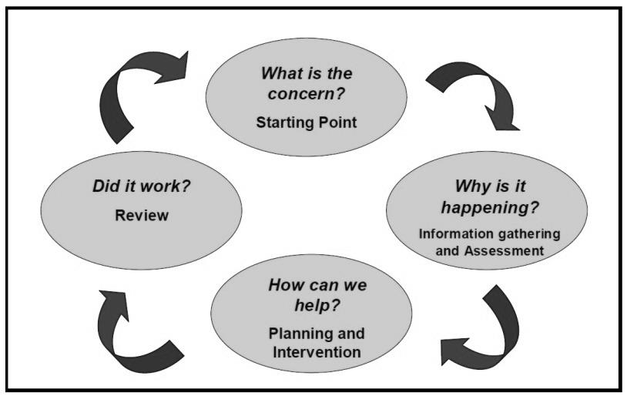
This problem-solving process is illustrated as follows:

Identification of educational needs is central to our policy and the new allocation model. By using the Continuum of Support framework, we can identify pupils’ educational needs, to include academic, social and emotional needs, as well as needs associated with physical, sensory, language and communication difficulties. This, in turn, allows us to identify and respond to needs in a flexible way.

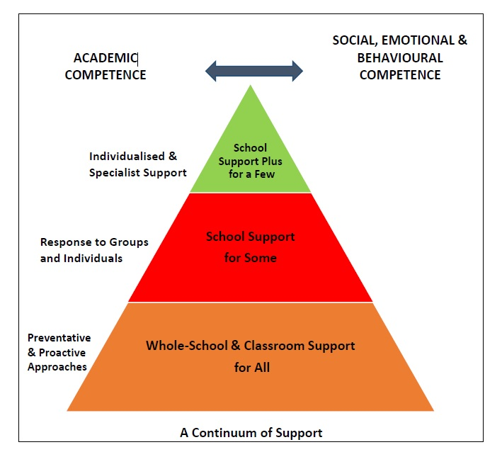
The Continuum of Support suggests the following levels of support:

STAGE 1 CLASSROOM SUPPORT
Classroom Support is the most common, and typically the first response to emerging needs. It is a response for pupils who have distinct or individual educational needs and who require approaches to learning and/or behaviour which are additional to or different from those required by other pupils in their class. Problem-solving at this level typically begins when a parent or teacher has concerns about an individual pupil. The teacher, SENCO and parents discuss the nature of the problem and consider strategies which may be effective. Classroom Support incorporates the simple, informal problem-solving approaches commonly used by class teachers to support emerging needs.

STAGE 2 SCHOOL SUPPORT
In some cases, interventions at classroom support level are not enough to fully meet the pupil’s special educational needs. School Support may, therefore, be required. The class teacher needs to involve the Special Education Teacher Team (SET Team) in the problem-solving process at this point and it involves more systematic gathering of information and the development and monitoring of a School Support Plan.

STAGE 3 SCHOOL SUPPORT PLUS
If a pupil’s special educational needs are severe and/or persistent, they are likely to need intensive support. School Support Plus will generally involve personnel outside the school team in the problem solving, assessment and intervention process. However, the information from Classroom and School Support work will provide the starting point for problem-solving at this level. Classroom support and school support will continue to be an important element of his/her individual education plan.

A more comprehensive explanation of each stage can be found in the Continuum of Support – Guidelines for teachers https://www.education.ie/en/Schools-Colleges/Services/National-Educational-Psychological-Service-NEPS-/neps_special_needs_guidelines.pdf

Information Gathering and Assessment
Assessment is part of what a class teacher does on a daily basis for all children. Some methods may include self-assessment, questioning, teacher observation, portfolios of work and teacher-designed tasks and tests. The information gathered enables the teacher to plan learning experiences based on the appropriate objectives from the curriculum.

In order to identify pupils who may require supplementary teaching, screening; including standardised testing, is carried out in all classes annually and further diagnostic testing may need to take place. The information gathered from these formal assessments is then used to inform decisions for support and pupil’s support plans.

Assessment and Screening Tests:
In our school we carry out the following assessment procedures annually:

- Junior Infants: Ready Set, Go Maths Assessment,
- Senior Infants: MIST (Middle Infant Screening Test), Ready Set, Go Maths Assessment, Drumcondra Tests of Early Numeracy (DTEN)
- 1st class: Drumcondra Reading, Sigma T
- 2nd class: Drumcondra Reading, Sigma T and NNRIT (New Non-Reading Intelligence Test)
- 3rd class: Drumcondra Reading, Sigma T, Drumcondra Spelling Test
- 4th class: Drumcondra Reading, Sigma T and NNRIT (New Non-Reading Intelligence Test), Drumcondra Spelling Test
- 5th class: Drumcondra Reading, Sigma T, Drumcondra Spelling Test
- 6th class: Drumcondra Reading, Sigma T, Drumcondra Spelling Test

Reading Recovery and Maths Recovery tests are carried out on selected children from Senior infants (RR) and First class (RR & MR).

New pupils from 2nd – 6th class will be tested using the NNRIT if they do not already have a NNRIT Quotient.

We continually review the assessment and screening tests that we use in order to balance the needs of our pupils and the need to provide information for appropriate support. Therefore we may deviate from the above list prior to the review date.

Inventory of Test Materials
Screening Tests

- Belfield Infant Assessment Profile (BIAP)
- Middle Infant Screening Test (MIST)
- New Non- Reading Intelligence Test (NNRIT)
- Non-Verbal Reasoning Test (NVRT)
- Micra-T
- Drumcondra Reading
- Drumcondra Spelling
- Sigma-T
- Dyslexia Screening Test (DST – J)
- Dyslexia Screening Test (DES 2)

- Ballard Westwood
- Dyscalculia Screener (GL assessments)

Diagnostic Tests
In our school the following tests are available for administration:
- Jackson Phonics Test  - Diagnostic Reading Analysis (Crumpler & McCarthy)  - RAIN Sentence Reading Test  - Aston Index  - Quest Maths tests (Junior)  - Infant Reading Test (Brimer & Rabane)  - Woodcock Johnson Test  - Maths Tracker | - Maths Recovery screening tests  - Reading Recovery Observation Survey  - Ted Ames Diagnostic Reading Programme  - NEPS Word Test  - Early Literacy Test  - BURT Reading Test  - Schonell Reading and Spelling  - York Assessment for Reading Comprehension (YARC)  - Reynor Phonic Checklist.

Prevention and Early Intervention Strategies
Our strategies for preventing learning difficulties include:
- The development of agreed approaches to the teaching of Literacy and Numeracy in order to ensure progression and continuity from class to class
- Ongoing structured observation and assessment of the language, literacy and numeracy skills of pupils in the infant classes to facilitate early identification of possible learning difficulties
- Close collaboration and consultation between the Infant Teacher and the SET team.
- Promotion of literacy e.g. Print-rich environment, First Steps Literacy Programme, DEAR (Drop Everything and Read)
- Promotion of Numeracy e.g. Ready Set Go Maths, Mata Sa Rang, Maths for Fun
- Parental involvement in promoting literacy and numeracy e.g. Maths for Fun, Homework Policy Guidelines for Parents, Read To Succeed, Library Trip
- Differentiation – adapting the learning environment
- In-class support from the SET team – Station Teaching
- Aistear
- Withdrawing individuals/groups
- Reading Recovery
- Maths Recovery
- Literacy Lift Off!
- Peer tutoring

Meeting the Needs and Allocating Resources

Once pupils needs have been identified, Special Education Teachers (SETs) address these needs as required. SETs effectively meet pupils’ needs in a variety of ways. We aim to strike a balance between in-class support, group and individual support while ensuring that the needs of children with additional needs are met.

Importantly, the level and type of support reflect the needs of individual pupils as set out in their support plans and are informed by careful monitoring and review of progress. In this way, following a period of intervention, some pupils may no longer require additional teaching supports; some may require the same level, while others may require more intensive supports.

In planning the allocation of additional teaching supports, the over-riding principle is that resources are deployed to address the identified needs of pupils. Importantly, those with the highest level of need should have access to the greatest level of support. We consider methodologies best suited to promoting meaningful inclusion such as differentiation, station teaching and small group teaching. In addition to literacy and numeracy difficulties, many pupils will have specific needs in areas such as oral language, social interaction, behaviour, emotional development, motor skills and application to learning.

As a SET team, we review all support and re-allocate resources for the second half of the academic year as required. However we will review/allocate or reallocate resources at any point throughout the academic year if required.

We cross-reference the needs of pupils at School Support and School Support Plus levels and consider common needs that can be met by grouping, to ensure effective and efficient teaching and learning approaches.

SELECTION PROCESS FOR ALLOCATING ADDITIONAL TEACHING SUPPORT
Stage 3 School Support Plus | - Children with identified complex needs by an external professional such as a  - Physical Disability  - Hearing Impairment  - Visual Impairment  - Emotional Disturbance  - Moderate General Learning Disability  - Severe/Profound General Learning Disability  - Autistic Spectrum Disorder  - Assessed Syndrome  - Specific Speech and Language Disorder/Impairment  - Dyspraxia  - Specific Learning Disability (Dyslexia)  - School refusals  - Children who need the highest level of support | Individual Education Plans | Type of Support  In-Class Support  Station-Teaching  Group Withdrawal  Individual Withdrawal  Personnel  SET teacher  Class Teacher  Outside Agencies  SNA
Stage 2 School Support | - Prevention and Early Intervention Programs (Reading/Maths Recovery, Ready Set, Go Maths, Aistear)  - Children on or under the 10th Percentile in Literacy Standardised Tests and/or Numeracy Standardised Tests  - Children with an identified need assessed by external professionals who are not on or below the 10th percentile in Literacy/Numeracy such as  - Borderline Mild General Learning Disability  - Mild General Learning Disability  - Specific Learning Disability  - Attention Deficit Disorder/Attention Deficit Hyperactivity Disorder  - Children who have not made adequate progress after interventions at Stage 1  - Children whom English is an additional language | Group or Individual Profile and Learning Programme | Type of Support  In-Class Support  Team-Teaching  Group Withdrawal  Individual Withdrawal  Personnel  SET teacher  Class Teacher

Timetabling

When drawing up timetables it is important to remember that:
- timetables should be continually reviewed
- children should not miss the same subject each time they are withdrawn

Tracking, recording and reviewing progress

Provision for pupils with special educational needs is enhanced through clear identification processes and careful planning of interventions to address academic and/or personal and social development needs. Identification of needs, planning, target-setting and monitoring of outcomes are essential elements of an integrated and collaborative problem-solving process.

Student Support File
We use a Student Support File to plan interventions and to track a pupil’s pathway through the Continuum of Support. It facilitates us in documenting progress and needs over time and assists us in providing an appropriate level of support to pupils, in line with their level of need.
Our Student Support File is based on the NEPS template. Our support files may include some/all of the following:
- Cover sheet with pupil’s details
- A log of actions
- Record of support received
- Standardised/Diagnostic test scores
- Support plans (See below)
- Checklists

A Classroom Support Plan file is opened when a child is placed on Stage 1 of the Continuum of support. The class teacher will keep the Classroom Support Plan in her assessment folder and a copy of the information gathered is sent to the child’s SEN file in the SET’s filing cabinet. If/when a child is moved to Stage 2 on the Continuum then a student support file will be opened.

If, after a number of reviews, the child’s case is moved to School Support, this information is then transferred to a blue folder and into the child’s SEN file in the SENCO’s room. It is the responsibility of the class teacher and the allocated SET to access and update the information in the Student Support File. The same system is in place for children on School Support Plus (yellow folder).

Support Plans
We use three different support plans for the three stages of support on the Continuum of Support.

Stage 1 – Classroom Support
A Support Plan at stage 1 is a Classroom Support Plan (CSP). This is a simple plan which is drawn up by the Class Teacher which outlines the pupil’s additional educational needs and the actions, including individualised teaching and management approaches, which will be taken to meet the pupil’s needs. The plan may also include home-based actions to be taken by the pupil’s parents to support their child’s development. The Classroom Support Plan should include a review date. This could be at the end of a school term.

Stage 2 – School Support
A Support Plan at stage 2 is a Group or Individual Profile and Learning Programme (GPLP/IPLP). This plan is drawn up by the SET teacher in consultation with the class teacher. It will set out the nature of the pupil’s learning difficulties, define specific teaching, learning and behavioural targets and set a timescale for review. Additional teaching will be within a small group or on an individual basis or a combination of both either in class or on a withdrawal basis. Home-based actions may also be included. This plan should be viewed as working document.

Stage 3 – School Support Plus
A Support Plan at stage 3 is an Individual Education Plan (IEP). This plan is drawn up by the class teacher and appointed Special Education Teachers, in consultation with the child’s parents/guardians, professionals external to the school and (if appropriate) the child, based on the information gathered. It will set out:
- The nature and degree of the pupil’s abilities, skills and talents
- The nature and degree of the pupil’s special educational needs
- The present level of educational performance of the pupil
- The special education and related support services to be provided to the pupil including:

- Specific programmes to be implemented
- Specific equipment/materials and/or IT supports, if required to support learning and access to the curriculum
- Support required from a Special Needs Assistant (SNA), if appropriate
- The targets which the pupil is to achieve over a given period
- The pupil’s priority learning needs
- Review Date

SEN Records
Individual SEN Files
All pupils’ SEN files are stored in a locked filing cabinet in the records room. It is the responsibility of SETs to update and manage the files of the children on school support and school support plus that they support. It is the responsibility of the class teacher to update and manage the SEN files of children on classroom support. The following should be stored
- Student Support File (Blue)
- Psychological Report & any other relevant reports (Yellow)
- Copy of referrals made to outside agencies (Red)

Whole Class SEN Files
Whole class tracking records are stored in a pink folder in the Records Room (SI – 6th Class). It is the class teachers’ responsibility to update these records and the responsibility of the SEN Coordinator to manage these. The following should be digitally stored on:
- Whole class test results (SIGMA – T, Drumcondra Reading, NNRIT & MIST) – Databiz
- SEN children in receipt of interventions record sheets – NAS

Communication between SET Team/Principal/Class Teachers
SET timetables have been organised so that 2.20-3.00pm each Friday is our designated co-ordination time. This allows all staff the opportunity to attend pupils support planning meetings, SEN consultation/planning/review meetings and Class Teacher/SEN review meetings. This flexibility ensures adequate cover for class teachers and also facilitates regular SET team planning meetings with the principal.

Health and Safety Issues
Every staff member and pupil is entitled to a safe, secure environment and to be treated with due respect. All appropriate measures are taken to ensure the safety of each pupil with SEN. When a place is offered to a child with SEN, every effort will be made to ensure that the supports to which the child is entitled are in place as soon as possible. Staff members will be informed of any potential risks and, where necessary, individual plans will be drawn up and implemented.

Supervision/Child Protection
- Where pupils receive support on a one-to-one basis, the SET teacher is responsible for ensuring that both themselves and the pupil are visible through the glass panel in the door.
- Where the there is no glass panel, the door of the room should remain open.
- Where a child has access to an SNA, they may withdraw the child from the class if a plan is in place with the class teacher.

Ratification and Communication

Implementation and Review
This policy will be implemented from September 2023. It will be reviewed in June 2026 by the Special Education Team and all staff at Castletown Girls’ National School.

Signed: _____________________ Date: ___________
(Chairperson)

