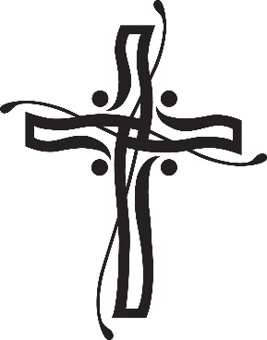
Castletown Girls’ School, Castletown Road, Dundalk, Co. Louth A91 P957
Tel: (042) 9334574. Roll No: 14651U
Email: castletowngs@gmail.com

Dear Parents/ Guardians,

The following is the agreed report of the Board of Management following a meeting on the 19th March 2024.

Agreed Report
- Our new chairperson Martina Rafferty was welcomed by Lisa Murphy and introduced herself to all board members. She was very helpful and complimentary of the school and staff. As a past principal she has a wealth of knowledge and will be a great asset to our school.
- Ms. Murphy gave her principals report including all minor works carried out recently in the school, dates for religious sacraments and staffing schedules for next year. She thanked the parents for their contributions to recent events in our school and is eager to continue parental involvement in our school.
- Policies ratified by the board included our updated ICT policy and In School Management Policy.
- The Board were very impressed by all recent events and activities organised in the school and they wish to express their gratitude and congratulations to all involved. They wanted to let everyone know that all the hard work and commitment was noticed and appreciated.

Yours sincerely,
Lisa Murphy
Secretary to the B.O.M.

